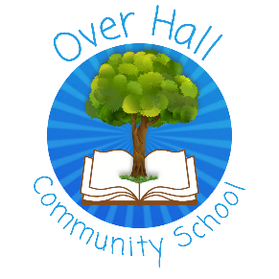
EYFS
Knowledge and Understanding of the World
What should I already know? |  | What will I know by the end of Autumn
- Begin to understand the need to respect and care for the natural environment and all living things.  - Plant seeds and care for growing plants.  - Understand the key features of the life cycle of a plant and an animal. |  | You will be able to:  - describe the weather  - monitor the weather each day  - explain how our school landscape changes in Autumn and Winter  - use your senses to describe those changes

Vocabulary
To use | To hear
rain – water falling from clouds in the sky. | weather – describing what it is like outside daily.
snow – frozen water falling from clouds in the sky. | season – Spring, Summer, Autumn, Winter
wind – air blowing trees, leaves and on faces. | Winter – its cold and the days are short.
sun – it lights up the day sets at night. | Spring -the flowers are coming back, it’s getting warmer.
cold – you need your coat to go out. | Summer – its hot and the days are long.
hot – we wear shorts and t-shirts; the sun is out. | Autumn – the leaves are falling off the trees, it’s getting colder.
see – what our eyes can notice around us | senses – what we see, feel and hear.
feel – what we notice when we touch something; is it rough, smooth, warm, cold? | rough – when something scratches when we touch a surface or material
hear – what our ears notice; quiet and loud noises, inside and outside the classroom. | smooth – when our hand slips across a surface or material

