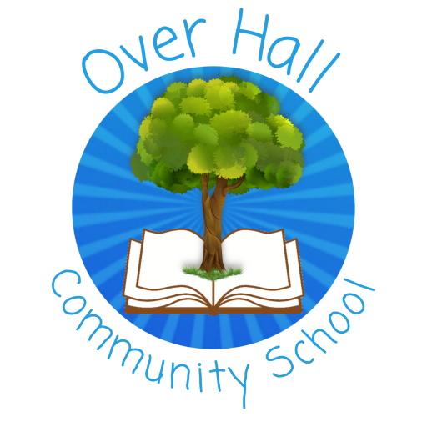
Art Policy

Date policy last reviewed: | January 2024

Signed by:
 | Headteacher | Date:
 | Chair of governors | Date:

Last updated: 10th January 2024

Contents
- Purpose of Study
  - Intent
  - Implementation
  - Impact
- Subject Content
  - Early Years Provision
  - Key Stage 1 Pupil Objectives
  - Key Stage 2 Pupil Objectives
- Roles and Responsibilities
- Cross-Curricular Links
- Assessment and Reporting
- Monitoring and Review

Purpose of study
Art embodies some of the highest forms of human creativity. A high-quality art education should engage, inspire and challenge pupils, equipping them with the knowledge and skills to experiment, invent and create their own works of art, craft and design. As pupils progress, they should be able to think critically and develop a more detailed and thorough understanding of art. They should also know how this subject reflects and shape our history, and contributes to the culture and creativity of our nation.

Statement of Intent:

Here at Over Hall, the aim of our high-quality Art curriculum is to engage, inspire and challenge pupils. Our curriculum enables the children to be equipped with the knowledge and skills to experiment, invent and create their own works of Art. Over time, our curriculum supports the development of being able to think critically and develop a more detailed understanding of this subject. Also, we aim for the children to gain an insight into how Art reflects and shapes our history and contributes to the culture and creativity of our nation.

We aim to ensure that all children:
- Produce creative work, exploring their ideas and recording their experiences.
- Become proficient in drawing, painting, sculpture and other art techniques.
- Evaluate and analyse creative works using the language of Art.
- Know about great artists and designers, and understand the historical and
cultural development of their Art forms.
Implementation:

Art is interwoven into the school’s topic work, making meaningful links to other elements of the curriculum. This may be through drawing on knowledge and inspiration from art from other cultures, artists from particular periods in history, or art that sends a certain message.

Each year group will have three main art projects throughout the year, each with a differing focus. Drawing occurs throughout each unit of work, as children begin to explore and experiment with ideas. Children will be developing their understanding of line, mark, tone, form and texture. A specific artist or designer will be focussed upon at least once a year to inspire ideas and provide opportunities to create artwork in the style of a variety of artists. Children will analyse their work, explore their methods of working and consider how they can create their own pieces in that particular style. The final project will look at art in a much broader sense. Children will endeavour to produce a piece of work in a different medium, which could be: digital media, painting, textiles, printing, 3-D or collage.

Subject content

Early years provision

Activities and experiences for pupils will be based on the seven areas of learning and development, as outlined in the DfE’s ‘Statutory framework for the early years foundation stage’.
- communication and language.
- physical development.
- personal, social and emotional development.
- literacy.
- mathematics.
- understanding the world.
- expressive arts and design.

All activities will adhere to the objectives set out in the framework.
Key Stage 1 Pupil Objectives:
During Key Stage 1, pupils will explore a curriculum which will allow them to:
- Use a range of materials creatively to design and make products.
- Use drawing, painting and sculpture to develop and share their ideas, experiences and imagination.
- Develop a wide range of art and design techniques in using colour, pattern, texture, line, shape, form and space.
- Know about the work of a range of artists, craft makers and designers, describing the differences and similarities between different practices and disciplines, and making links to their own work.

Key stage 2 Pupil Objectives:
Key Stage Two pupils will continue to explore the above points, alongside being able to:
- Create sketch books to record their observations and use them to review and revisit ideas.
- Improve their mastery of art and design techniques, including drawing, painting and sculpture with a range of materials.
- Know about great artists, architects and designers in history.

Roles and responsibilities
The subject leader is responsible for:
- Preparing policy documents, curriculum plans and relevant documents to support the work for the subject.
- Reviewing changes to the national curriculum and advising on their implementation.
- Monitoring the learning and teaching of art, providing support for staff where necessary.
- Ensuring the continuity and progression from year group to year group.
- Encouraging staff to provide effective learning opportunities for pupils.
- Helping to develop colleagues’ expertise in the subject.
- Organising the deployment of resources and carrying out an annual audit of all art-related resources.
- Liaising with teachers across all phases.
- Communicating developments in the subject to all teaching staff.
- Leading staff meetings and providing staff members with the appropriate training.
- Organising, providing and monitoring CPD opportunities in the subject.
- Ensuring common standards are met for recording and assessing pupil performance.
- Advising on the contribution of maths to other curriculum areas, including cross-curricular and extra-curricular activities.
- Collating assessment data and setting new priorities for the development of maths in subsequent years.

The classroom teacher is responsible for:
- Acting in accordance with this policy.
- Ensuring progression of pupils’ art skills, with due regard to the national curriculum.
- Planning lessons effectively, ensuring a range of teaching methods are used to cover the content of the national curriculum.
- Liaising with the subject leader about key topics, resources and support for individual pupils.
- Monitoring the progress of pupils in their class and reporting this on an annual basis to parents.
- Reporting any concerns regarding the teaching of the subject to the subject leader or a member of the SLT.
- Undertaking any training that is necessary in order to effectively teach the subject.

Cross-curricular Links

Wherever possible, the Art curriculum will provide opportunities to establish links to other curriculum areas.

English:
- Art enhances the teaching of English by encouraging pupils to ask and answer questions about the starting points for their work.
- Pupils can compare ideas, methods and approaches in their work, comparing and sharing ideas with their peers.
- Pupils can use art when creating and drawing images and designs in their English work, e.g. when creating stories with pictures.

Maths:
- Art contributes to the teaching of Maths by enhancing pupils’ understanding of shape, space and measurement.

PSHE:
- Art is used to encourage pupils to discuss their feelings about their own work, as well as their peers’ work, and explain their work, methods and approaches.

SMSC:
- Teaching Art offers opportunities to support the social development of pupils through the way they are expected to work with each other in lessons.
- Art helps pupils to develop respect for other pupils’ abilities. Working in groups encourages collaboration and gives pupils the opportunity to learn from each other and share ideas and feelings.
- Pupils develop an appreciation of different times, cultures and religions through their work on famous artists.

ICT:
- Pupils explore shape, colour and pattern in their work, and can collect visual information to help them develop their ideas.
- Pupils can record their observations and manipulate them through photography, editing or painting software to create their own designs.
- Pupils can use the internet to explore famous artists and designers.

Assessment and Reporting

Foundation Stage
Children are formatively assessed through observations and evidence of completed work throughout the year. Their progress and attainment is recorded using the statements of development and the Early Learning Goals outlined in the EYFS Curriculum and is reported to the Art Subject Lead at the end of each academic year.

Key Stages 1 and 2
Staff record the attainment of pupils each term against each of the learning objectives for their Key Stage and make a judgement of Emerging, Expected or Exceeding for each pupil.
This is done through Teacher judgement and this information is then reported to the Art Subject Lead.

Monitoring and review
- This policy will be reviewed on an annual basis by the subject leader.
- The subject leader will monitor teaching and learning in Art at Over Hall School, ensuring that the content of the national curriculum is covered.
- Any changes made to this policy will be communicated to all teaching staff.

