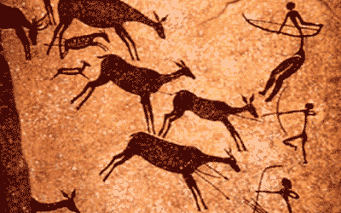
KNOWLEDGE ORGANISER

What should I know already?  Drawing  - Drawings can be made using a variety of media (pencils, rubbers, crayons, pastels, felt tips, charcoal, ballpoints, chalk).  - Lines, marks and shapes can be made from observations or using imagination.  - The tone of the drawing can be changed by drawing light/dark lines or shapes.  - Textures can be made by rubbing or copying.  Painting  - A variety of tools and techniques can be used including different brush sizes and types.  - Colours can be mixed and matched to artefacts and objects.  - Artwork can be on different scales (large or small).  - Tools and techniques can help you in layering paint and mixing media.  - Texture can be created by adding sand or plaster.  - Identify and name primary and secondary colours.  - Which primary colours mix to make the secondary colours.  Year 3 Art Drawing and Painting | Questions to explore: |  |  | Painting Techniques | What skills will I learn? |  | Key Vocabulary  - Experiment with different effects and textures including blocking in colour, washes, thickened paint creating textural effects.  - Work on a range of scales e.g. thin brush on small picture etc.  - Create different effects and textures with paint according to what they need for the task.  Colour  - Use more specific colour language  - Mix and use tints and shades  Line  Mark  Form  Shape  Tone  Texture  Pencil Grade  2D  3D  Wash  Scale  Effect  Pattern  Colour Wheel  Primary Colour  Secondary Colour  Tertiary Colour  Tint  Shade
Who were the first artists?
How was the paint made for a cave painting? How was it applied to the walls? What did the images represent?
Why do archaeologists think most of the hand prints depicted in cave paintings were created by women?
What would the surface of a cave wall feel like? How could we create a textured surface on a smooth piece of paper?How would you compare drawing on textured paper to drawing on smooth paper?
Could you paint with your fingers instead of a paintbrush?
Was clay accessible to use during the Stone Age?
Was charcoal a tool for drawing that was available during the Stone Age? How do we know?
What tools would have been used to paint during the Stone Age period of history? How has this changed over time?
How can we use the materials available to us to create a replica Iron Age tool?
What would you use? How would you construct it?
What will I know by the end of the unit?
Did you know that drawing pencils have different grades?  The degree of hardness of a pencil is printed on it.  B stands for "black". These pencils are soft.  H stands for "hard".  HB stands for "hard black", which means "medium hard".  F stands for "firm".  Sometimes the alphabetic characters have numbers before them. They make a precise statement about the hardness or colour of the pencil. The higher the number, the harder, softer or blacker the pencil is. |  | Pencil Grades  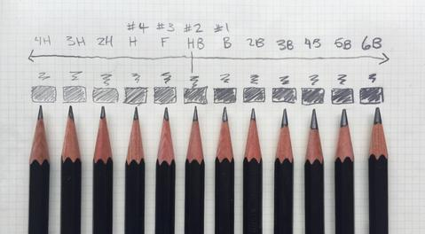 |  | The Colour Wheel
Prior Knowledge:
Primary colours cannot be made from other colours. Artists create all the other colours of the rainbow by mixing together the primary colours.
Secondary colours are made by mixing two primary colours. Each secondary colour is made from the two primary colours closest to it on the colour wheel.

New Knowledge:
Tertiary colours made by mixing equal amounts of a primary colour and a secondary colour together. There are six tertiary colours. On the colour wheel, they sit between the primary and secondary colour they are mixed from.

What colours will you use to represent your Stone age to Iron Age artwork?
How will you mix colours to make your chosen colour?

Observational drawing is the act of drawing something right in front of you. The aim is to make the drawing look as similar to the object.  Top tips: When drawing from something in front of you, make sure to fully explore it, before drawing it.  Have a go at doing some quick drawings of the object, before trying for a longer period of time.  Use the ‘tick tock’ method! Make sure to look at the object as much as you are looking at your paper. Your head should move almost as fast as a ticking clock. This makes the drawing more accurate. |  | Observational Drawing  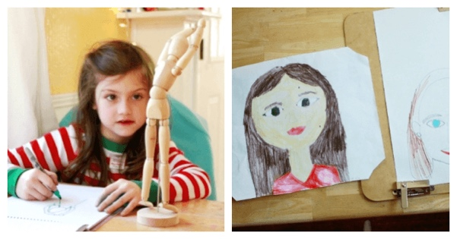
If you’re drawing from a picture or another piece of art, turn it upside down! The brain likes to make sense of what it is looking at, which can make it trickier to draw things. If the piece is turned upside down, the brain only sees shapes, which makes it far easier to draw!

