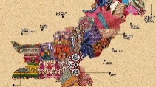
KNOWLEDGE ORGANISER

What should I know already?  Year 5 Art Digital Media |  | What skills will I learn? |  | Artist Study – David Hockney |  | Key Vocabulary  Hockney  Pop Art  Movement  Influential  Portrait  Auction  Landscape  Digital Media  Observational  Tools  Techniques  Amendments  Improvements  E-resources  Accurate  Impact  Criteria  Replicate  Abstract
- Explore ideas using digital sources i.e. internet, CD-ROMSs.  - Record visual information using digital cameras, video recorders.  - Using a simple graphics package to create images and effects with.  - Lines by changing the size of brushes in response to ideas.  - Shapes using eraser, shape and fill tools.  - Colours and Texture using simple filters to manipulate and create images.  - Use basic selection and cropping tools.  - Record, collect and store visual information using digital cameras, video recorders.  - Present recorded visual images using software.  - Use a graphics package to create images and effect with.  - Lines by controlling the brush tool with increased precision.  - Experiment with colours and textures by making an appropriate choice of special effects and simple filters to manipulate and create images for a particular purpose. |  | 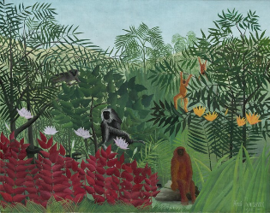  - Record, collect and store visual information using digital cameras, video recorders.  - Present recorded visual images using software.  - Use a graphics package to create and manipulate new images.  - Be able to import an image (scanned, retrieved, taken) into a graphics package.  - Understand that a digital image is created by layering.  - Create layered images from original ideas. |  | David Hockney was born on 9th July 1937. He is an English painter, craftsman, printmaker, stage designer, and photographer. Hockney has owned residences and studios in Bridlington, and London, as well as two residences in California, where he has lived intermittently since 1964.  As an important contributor to the pop art movement of the 1960s, he is considered one of the most influential British artists of the 20th century.  On 15 November 2018, Hockney's 1972 work Portrait of an Artist (Pool with Two Figures) sold at Christie's auction house in New York City for $90 million (£70 million), becoming the most expensive artwork by a living artist sold at auction. This broke the previous record, set by the 2013 sale of Jeff Koons's Balloon Dog (Orange) for $58.4 million. Hockney held this record until 15 May 2019 when Koons reclaimed the honour selling his Rabbit for more than $91 million at Christie's in New York.  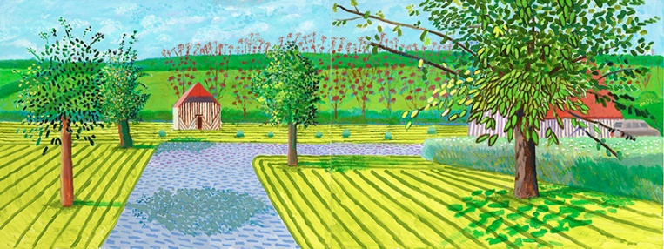
What will I know by the end of the unit?
- Who David Hockney is. What he is famous for. What his style of artwork is and how this was important and influential at the time.
- How to create work influenced by Hockney, including style, shapes, colour, texture and mood.
- Use online sources to collect, retrieve and store visual images.
- Use online sources to edit and manipulate images to create new images.
- To layer different colours, shapes and images to create a piece of art.
- To create a landscape piece of art inspired by Hockney and our local area.

