Expressive Arts and Design:  - Learns new songs from local bands and dances.  - Make a map of Winsford using construction materials.  - Makes representations of their own home.  - Takes part in role play in the home corner.  - Use mirrors to create self portraits  - Learn to sing the nursery rhymes:  - Pat-a-cake  - 1,2,3,4,5 Once I Caught A Fish Alive  - 5 Little Speckled Frogs  - Twinkl Twinkl Little Star  7. Learn to sing the songs:  - 123 Its Good To Be Me  - Dingle, Dangle, Scarecrow |  | Understanding the World  1. Create a family tree  2. Talk about people that help us and their occupations in our community  3. Look at the different types of houses in Winsford; which are old and which are new  4. Take photos using an ipad of the local area  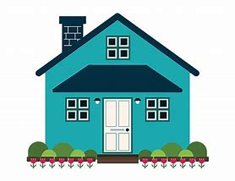  5. Use Google Earth to look at Winsford and the UK  6. Explore the idea of past and present based on ourselves and our surroundings  7. Use mirrors and labelling parts of the face and compare with others  8. How did they feel when they came to school? How do they feel now? Explore the idea of past and present.  9. Who is super around us? What qualities do they have? Explore people who help us.
Personal, Social and Emotional  1. Plays with friends in the role play home area. Acting out experiences from their own lives.  2. Children take risks and try new activities in the classroom.  3. Discussion around how we are all unique and celebrating our successes with others  4. Discussion are friendship, belonging, caring for each other  and positive relationships  5. Draw a picture of how we are unique and discussion about our superpowers  6. Discuss what qualities make someone super, how are we super? | Physical Development  1.Write labels to accompany photos  2.Use scissors to cut materials to make houses  3. Use den building equipment to build their ‘hide out’  4. Untangle the superheroes and animals  Within PE sessions:  - Develop confidence in fundamental movements  - Experience jumping, sliding, rolling moving over and under apparatus.  - Develop coordination  - Send and receive different objects with different body parts  - Work with others to control objects in space | Communication and Language  1 .Listen to new stories about homes and families  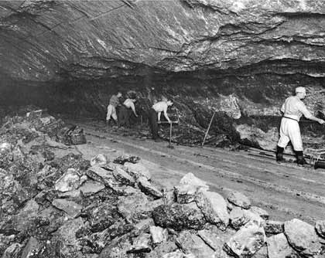  2 .Follows instructions to create models of houses and maps of the town.  3. Answers how and why questions about Winsford and their families.  4. Extends sentences to give explanations; uses tenses.  5. Uses the new vocabulary to do with Winsford in their everyday discussions and play.  6. Discussion’s around friendship and belonging based on class text | Celebrations Along the Way  -Roald Dahl Day  -Rosh Hashnah  -Recyle Week  -Yom Kippur  - European Day of Languages  -Sukkot  -National Poetry Day  -Harvest Festival  -Halloween
Famous Figures

Edward Jenner Mary Seacole
Glossary  Home – A place where a family lives for a long time.  House – A building for humans to live in.  Flat – a place to live usually without stairs within a larger building.  Bungalow – a house without stairs.  Winsford – a town in Cheshire.  Cheshire – a county in England.  England – A country within the UK.  Family – a group of people who often live together.  Occupation – a job.  Sound: a sound made represented by a letter or group of letters.  Grapheme: a letter or group of letters written down to represent a sound.  Phoneme: a single letter sounds.  Blend: to put a two or more sounds together to read a word.  Segment: to break down a word into separate phonemes.  Initial sound: the first phoneme in a word |  | Phonics  -Blend words using the taught sounds to orally blend words.  -Listen for the initial sound in words.  -Use magnetic letters to spell and read CVC words  -Read by sight the following words: the, to, I, no, go, into, little, of, ten  - Teach high frequency words: is, it, in, at, and, the  -Learn to read and write the following sounds:
Maths  -Matching objects which are the same and different  -Sort objects based on attributes  -Understand that sets of objects can be compared and ordered  -Compare objects based on size using language such as big, little, large, small, tall, long and short.  -Copy, continue and create simple repeating patterns  -Explore AB patterns   |  | 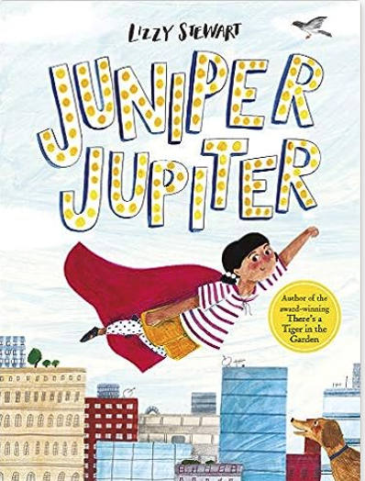  Writing outcomes:  - Superhero Narrative  - Letter  Further writing and mark making opportunities  - Draw and describe what makes your super sidekick? What makes them a good friend?  - Write a secret message for your side kick to read  - Make a den for your superhero to live in and label  - The superheroes are trapped. Can you untangle them?  - Will you be a good superhero? List your superpowers?  Additional Texts  Superbat by Matt Carr  Here Come the Superheroes: Raps and Rhymes to Save the Galaxyy  Newspaper Boy and Origami Girl by Michael Foreman  My Mum Is A Supermum by Angela McAllister  George Saves The World By Lunchtime by Dr Jo Readman  Take Off Your Brave by Nadim  Superworm by Julia Donaldson  Astro Girl by Ken Wilon-Max  The Day the Crayons Quit by Oliver Jeffers  SuperTato by Sue Hendra

