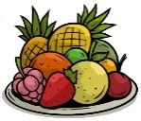
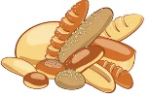
YEAR 5 D.T: FOOD – CELEBRATING CULTURE AND SEASONALITY
KNOWLEDGE ORGANISER
Preparing and Cooking Processes |  |  | Where Food Comes From |  |  |  |  | Key Vocabulary  Healthy & Varied Diet  Food/Meal Plan  Calories  Saturated Fat  Adding/ Substituting  Griddling  Steaming  Poaching  Seasonal Produce  Seasonality  Sustainability  Health & Safety
Preparing Processes  Preparing processes are the different ways that we get food ready to be eaten.  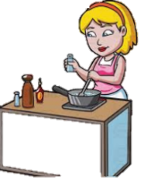  -Slicing: cutting food using a knife.  -Mixing: to blend ingredients together, using a spoon, blender, or whisk.  -Weighing/measuring: to get the right amount of an ingredient, using scales, table/teaspoons  Grating: to peel a layer off something (like carrots or cheese) using a peeler or grater.  -Serving: making food look nice on the plate.  -Adding/ substituting: changing the taste of food by adding or replacing ingredients. | Cooking Processes  Cooking processes are the different ways that we heat food before it is eaten.  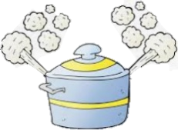  -Baking: to cook food in a heated oven.  -Boiling: to cook food in boiling (100°C ) water.  -Frying: to cook food in a pan of heated oil.  -Grilling: to cook food by putting it under a hot grill (like a radiator in a cooker).  -Griddling: to cook on a flat iron plate called a griddle.  -Steaming: to cook using steam, normally from boiled water.  -Poaching: to cook by simmering in a small amount of liquid. |  | 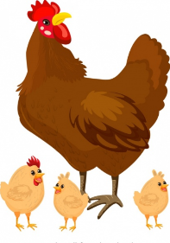  Grown, Raised, Caught  It is important to know that foods are grown, raised and caught more easily during certain seasons. This is called seasonality.  Some food is grown  - In order for us to get cucumbers, we need to grow a cucumber plant. Cucumbers grow on the vines of cucumber plants. In the UK, the cucumber season is between March and June, when they grow most naturally in the seasonal conditions.  Some food is raised  - In order for us to be able to eat chicken, we need to raise chickens. Eggs are laid by female chickens. In order to be sustainable, we need to know that most chicks are born in the spring/ summer seasons.  Some food is caught  - In order for us to get tuna, we need to catch the tuna-fish. There are also seasonal changes for caught food, as animals can migrate. E.g. a lot of tuna is caught between November-May in the Pacific off San Francisco.
Eating Sustainably
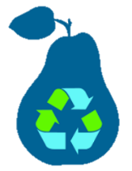
-With modern technology, it is possible to grow and rear food out of season.

-However, growing and rearing foods out of season consumes a lot of energy, because the process takes place in artificial conditions, and needs a lot of resources, for example heat, light, water and nutrients.

-Eating sustainably is about finding the right balance between your food needs and your food choices. It helps to reduce our carbon footprint.
A Healthy and Varied Diet
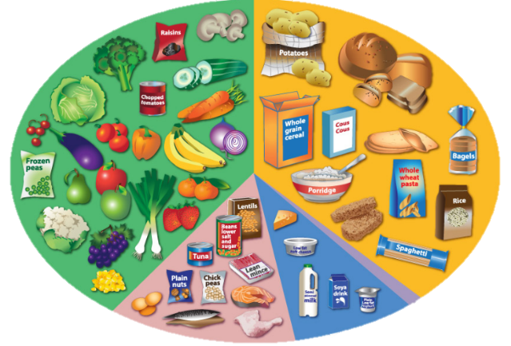
Food Groups
You should now know how much to eat of each food group
-Fruit and vegetables – Eat lots! About 5 portions per day.
Good for vitamins, minerals and fibre. Fresh, tinned and juices all count.
-Carbohydrates – Eat lots! Include in every meal.
Good for energy (carbohydrates), vitamins, minerals and fibre.
-Proteins – You should eat about 2-3 portions per day.
Good for muscle-building (protein), vitamins and minerals.
-Dairy – You should eat about 2-3 portions per day.
Good for muscle-building protein, vitamins and minerals.
-Fats and Sugars – Only eat occasionally and in small amounts.
Good for energy and fat reserves in small amounts. Cut down on saturated fats.
 |  |  | Food from Around the World
 |  |  | Seasonal Foods around the World  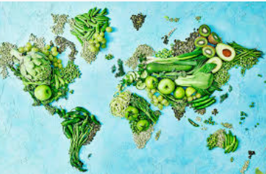  -It is important to remember that the seasons are different in different places over a year.  -In the northern hemisphere, spring takes place between March and May. In the southern hemisphere, spring is September to November.  Therefore, foods are in season in different places at different times of the year. Cucumbers can be naturally grown in the northern hemisphere March-June, and in the southern hemisphere October-December. |  |  | 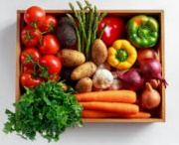  UK Seasonal Foods  Winter: Apples, Beetroot, Sprouts, Cabbage, Leeks, Mushrooms, Onions, Parsnips, Pears, Turnips.  Spring: Artichokes, Asparagus, Aubergines, New Potatoes, Rhubarb, Rocket, Spinach, Spring Greens, Spring Onions.  Summer: Blackcurrants, Broad Beans, Cherries, Chillies, Courgettes, Gooseberries, Garlic, Strawberries, Water Cress.  Autumn: Butternut Squash, Cauliflowers, Chicory, Elderberries, Marrow, Pumpkin, Wild Mushrooms, Squash.
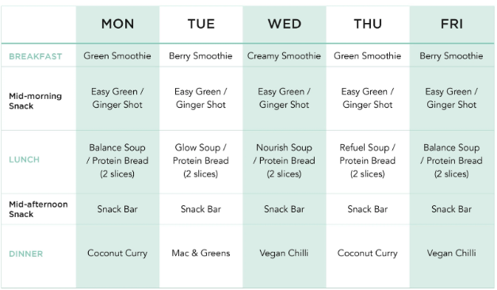
A Varied Diet
--In order to stay healthy, it is important that we eat a balanced diet of foods from each of the five food groups. Too much of any one food group is not healthy for us.

-You should be able to create a weekly food plan, incorporating a healthy and varied diet of foods across each day and the week.
-Your plan should apply your understanding of which foods within groups have advantages and disadvantages (e.g. ‘fish has less fat than red meat’ and ‘use a low-fat butter alternative).
-You may even be able to understand calories and how they work, and count these in your food plan!

Check the dates on food, and check for allergies & diet e.g. vegetarian, vegan.
Make sure that you clean up properly after yourself.
Use a food thermometer to check that food is cooked through.
Use different chopping boards and knives for raw meat & other foods. This stops bacteria spreading.
Washing your hands should be done before, during and after preparing food.
-Remove any jewellery and tie back long hair. Ideally, wear a hair net.
-Wash your hands with hot water and antibacterial soap, for at least 20 seconds.
-Wear an apron and roll up your sleeves. Tie your apron securely.
Health and Safety

