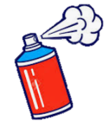
Year 3 Art Collage

KNOWLEDGE ORGANISER
What should I know already? |  | What skills will I learn? |  |  | Artist Study – Laura Shabazz |  | Key Vocabulary  Laura Shabazz  Collage  Materials  Techniques  Collect  Visual Vocabulary  Tear  Overlap  Layering  Represent  Textures  Upcycling
- Images can be created form a variety of media e.g. photocopies material, fabric, crepe paper, magazines etc.  - Different materials can be arranged and glued onto different backgrounds.  - Materials can be sorted and grouped for different purposes e.g. colour, texture.  - Collage includes folding, crumpling, tearing and overlapping papers.  - Collage can be created on different scales.  - Colours can be collected, sorted, named and matched appropriately for an image.  - Shapes can be created and arranged through collage.  - How to create, select and use textured paper for an image. |  | - Experiment with a range of collage techniques such as tearing, overlapping and layering to create images and represent textures.  - Use collage as a means of collecting ideas and information and building a visual vocabulary.  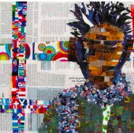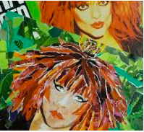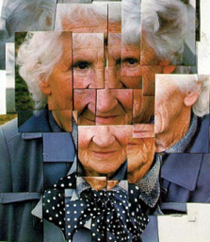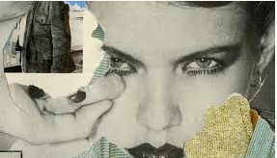 |  |  | - Shabazz was born into an artistic and musical family.  - Laura explores collage through upcycling the discarded magazines and books that she finds from recycling bins all over her town.  - She teaches guitar and has a part-time job so she creates her art at night when her family are asleep.  - She only uses paper and glue. She tears the paper by hand. Her larger pieces of art use hundreds of tiny scraps of paper. She gets straight lines by using the edges of paper and only occasionally uses scissors for precise shapes.  - Shabazz starts her art by finding images, creating basic sketches and getting a general idea of colours.  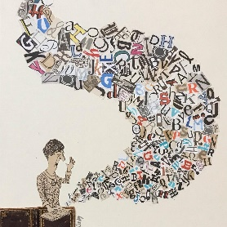  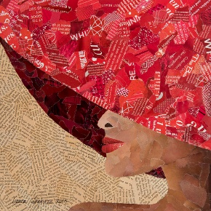  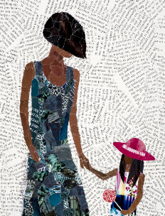  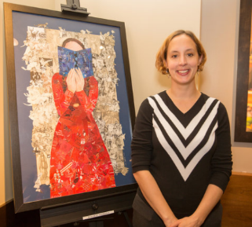
What will I know by the end of the unit?
 | - Artwork begins by collecting materials, developing ideas and trying initial ideas and experiments.  - Laura Shabazz is a collage artist who upcycles materials to create her artwork.  - Collage can be created using only paper and glue.  - There are different techniques to collage including tearing, overlapping and layering materials to create the final piece.  - Images can be created using different colours, tones, shades or light and dark materials.  - How to create a piece of artwork inspired by the artist Laura Shabazz. |  |  |  | Collage Ideas…
