 | Super 6  Learn to sing the nursery rhymes:  - Incy Wincy Spider  - Humpty Dumpty  - Jack and Jill  Learn the poem  -Here it comes  Learn the songs:  - When Santa got stuck up the chimney  - Up on the house top | Understanding the World  - Explore the natural world around them. Describe what they see, hear and feel.  - Name and describe people who are familiar to them.  - Understand some places are special to members of the community.  - Recognise that people have different beliefs and celebrate special times in different ways.  - Understand some places are special to members of the community.  - Recognise some similarities and differences between life in this country and life in other countries | Author Spotlight  Pippa Goodhart
Personal, Social and Emotional  1.Express their feelings and consider the feelings of others.  2. Show resilience and perseverance in the face of challenge.  3. Understand how to be a safe pedestrian  One Decision Units  Pink misses mummy  Blue explores road safety  Blue’s best friend  Green’ daddy moves out  Orange feels worried  Yellow play fights | Physical Development  1.Progress towards a more fluent style of moving, with developing control and grace.  Within PE sessions we are learning to  - balance beanbags  - move through hoops in different ways  - reach and stretch to get equipment  - make bridges and tunnels with our bodies  - travel over and under apparatus  - make shapes with our bodies  - perform actions to music  - copy, repeat and perform some basic actions to music | Communication and Language  -Listen to and talk about stories to build familiarity and understanding.  -Understand how to listen carefully and why listening is important.  -Learn new vocabulary.  -Engage in story times.  -Engage in non-fiction books. | Celebrations Along the Way  -Bonfire night  -Nursery Rhyme Week  -Remembrance Day  -Diwiali  -Anti-Bullying Week  -Road Safety Week  -Hanukkah  -Christmas Story
Famous Figures
Guy Fawkes
Glossary |  | Phonics  -Read individual letters by saying the sounds for them.  -Blend sounds into words, so that they can read short words made up of a known letter-sound correspondences.  - Read by sight the following words: he, she, we, me, was  - Teach high frequency words: I, no, go, to  Learn to read and write the following sounds:  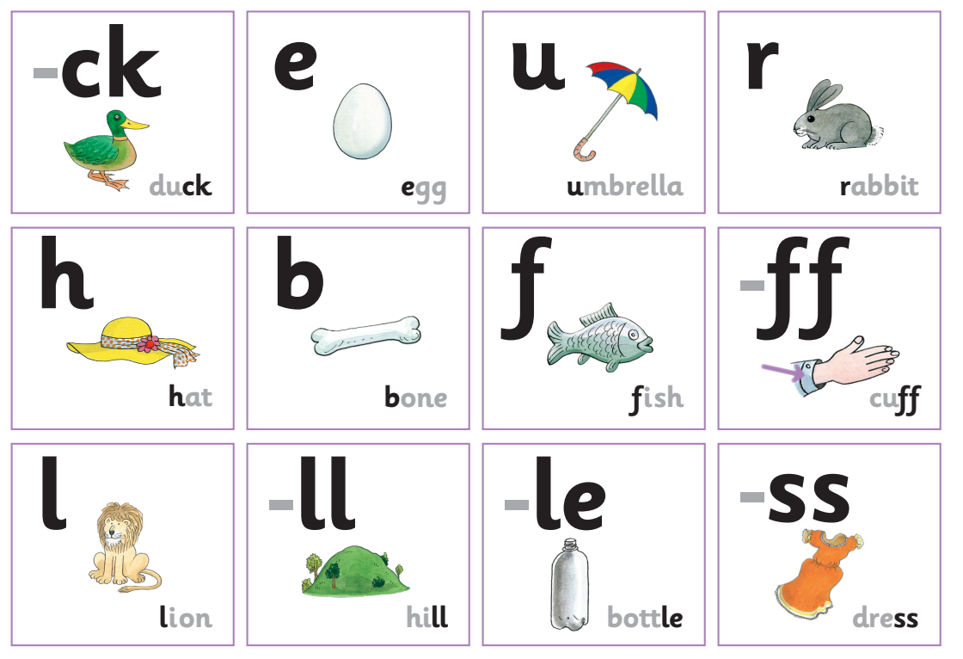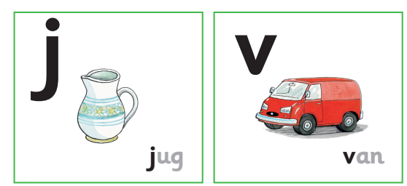
Maths  -Begin to understand that as we count, each number is one more than the number before.  -Recognise the pattern when counting back.  -Recognise circles and triangles and squares on everyday items  -Hear and begin to use positional language to describe how items are positioned in relation to other items.  -Explore quantity and say which sets have more and which have fewer items  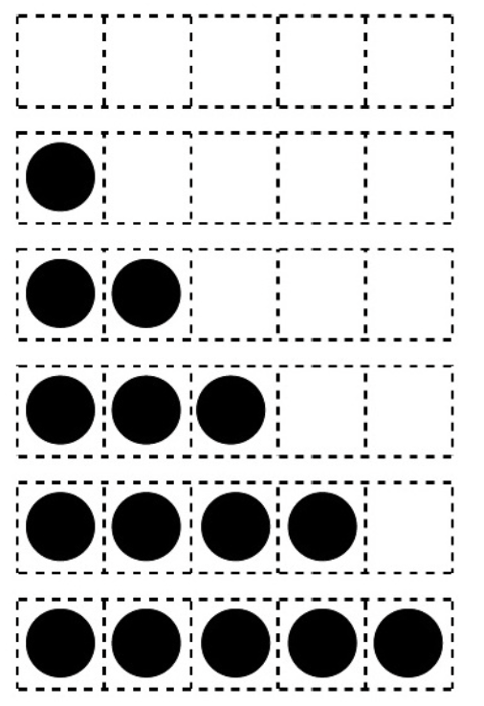  Learn that squares and rectangles have 4 straight sides and 4 corners  -Talk about night and day and order key events in daily routines.  -Use language such as day, night, morning, afternoon, before, after, today, tomorrow  -Identify representations of 1, 2 and 3.  -Subtise or count to find how many and make own collections up to 5 items  -Explore and notice the different compositions of 2 and 3  -Count on and back to 4  -Match number names we say to numerals and quantities.  R-epresent up to 5 objects on a five frame |  | Writing outcomes:  -Traditional Tale  -Set of instructions  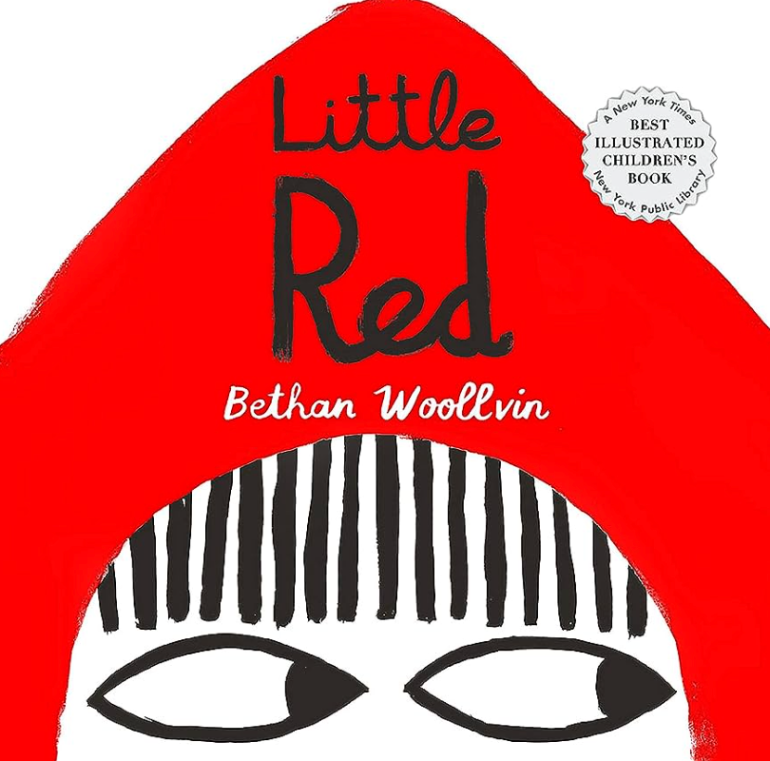  Further writing and mark making opportunities  - Create a get well soon card for Grandma  - Draw a picture of Little Red or the wolf and label their features.  - Write dialogue between Little Red and the wolf.  - Make a wanted poster of the wolf or another baddy.  - Write a list of things to put in a basket to take to Grandma’s house.  - Write a spine poem about a wolf.  Terrific 10  -Red Riding Hood – Much More Than A Story! Big Book:  -The Three Little Pigs – Much More Than A Story! Big Book:  -The Big Bad Wolf – by Jane Goulbourne  -The Three Little Pigs by Jane Goulbourne  -Bily and the Beast by Nadia Shireen  -You Choose Fairytales by Pippa Goodhart  -Shhh! By Sally Grindley  -Rosie’s Walk by Pat Hutchins  -Paws and Claws! All About Wolves of The World by Bobo’s Little Brainiac Books  -National Geographic Animal Encyclopedia:2500 Animals with Photos, Maps and More! By National Geographic Kids Magazine

