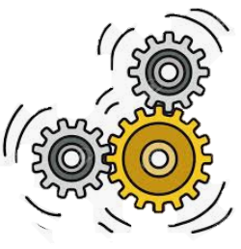
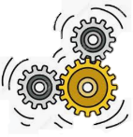
KNOWLEDGE ORGANISER
YEAR 1 D.T: MECHANISMS – SLIDERS AND LEVERS
Overview |  |  |  |  | Designing |  | Key Vocabulary  Mechanism  Slider  Slot  Lever  Fulcrum  Pivot  Guide/ Bridge  Design  Make  Evaluate
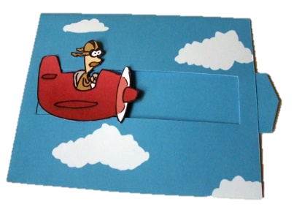  Sliders and Levers  Mechanisms are the parts that make something work.  -Mechanisms are all around us! Most objects that help us in our lives are made up of different mechanisms.  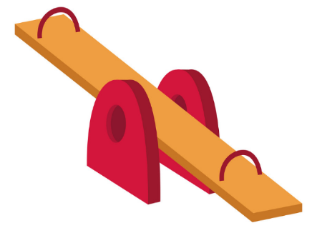  Sliders and Levers are mechanisms that make things move.  -Sliders help to move things from side to side and up and down.  Levers are slightly more complex. They use a fulcrum (a fixed point around which the lever can pivot) to make things move in arc (curve). |  |  |  |  | -Effective sliders and levers should move smoothly  -Effective sliders and levers should create a movement that is appropriate to the subject matter.  -You need to think about who your product is for – what is its purpose and who is going to use it?  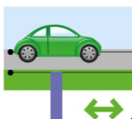  Sliders  -Consider where you will place the slot, and how long it will be. This will change how far your slider can slide! You also need to consider where to put your guide, so that the slider only moves where you want it to.  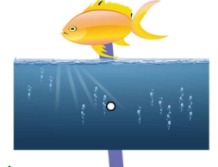  Levers  -Consider where you will position the fulcrum. The further it is from the object, the more that the subject at the end of your lever can move!
Example Mechanisms
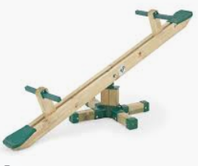  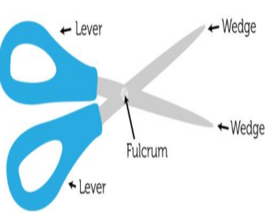 | Levers  Seesaw  Scissors |  | -A seesaw is one example of a lever mechanism. Seesaws are a narrow board supported by a fulcrum in the middle point between the two ends. As one end goes up, the other comes down!  -Scissors are another example of a lever mechanism. Scissors have two levers fixed –[handles are squeezed at one end of the levers, the blades come together at the other end.
 |  |  |  |  | Making & Evaluating
 |  |  |  |  | Making  -Sliders and levers can be made using card, lollipop sticks, or another thin, firm material.  Sliders  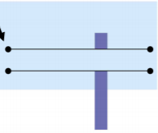  -Use a hole punch to as the starting point for your slot. Instead of a slot, you could attach a card strip to the back of your product.  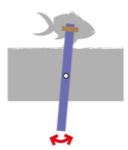  -Guides can be made using strips of card fixed with masking tape.  Levers  -To create the hole for the fulcrum, place the card backdrop over a piece of Blu Tack and pressing a pencil through. The fulcrum can be attached using a paper fastener. | Evaluating  -How well does your mechanism work? Does it move smoothly?  -Does it meet its purpose?  -Who would use your mechanism? What would they like about it?  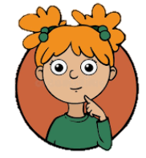  -Where did you position the fulcrum/ bridge?  -How did this affect the mechanism?  -What else could you do to improve your mechanism?
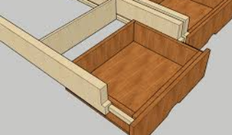  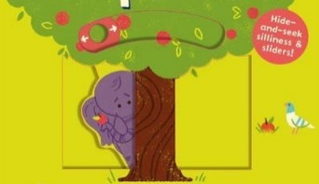 | Sliders  Children’s Books  Drawers |  | -Some children’s books contain slider mechanisms. As the slider is pushed/ pulled, characters/objects move up and down or side to side in the book.  -Drawers also work on a slider mechanism. As you pull/push the handle, drawers slide along a slider track inside the cabinet.

Follow the teacher’s cutting instructions carefully.
If you need to move around with scissors, hold around the closed blades, facing down.
Report all spillages & clean up properly after yourself.
Make sure that you are wearing the correct equipment for tasks.
Keep your work area and floor area clear – keep your belongings well clear.
-Walk safely and calmly around the classroom/ workshop.
-Wear an apron and roll up your sleeves.
-Remove any jewellery and tie back long hair.
Health and Safety

