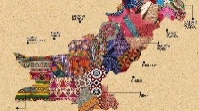
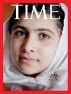
KNOWLEDGE ORGANISER

What should I know already?  Year 5 Art Textiles |  |  | Key techniques: Batique and Stitching |  | Key Vocabulary  Fabric  Thread  Needle  Embroidery  Batik  Media  Overlap  Layer  Texture  Effect  Henna  Pattern  Ink  Applique  Pattern Piece  2D  3D  Structure
- Match and sort fabrics and threads for colour, texture, length, size and shape.  - Change and modify threads and fabrics, knotting, fraying, fringing, pulling threads, twisting, plaiting.  - Cut and shape fabric using scissors/snips.  - Apply shapes with glue or by stitching.  - Apply decoration using beads, buttons, feathers etc.  - Apply colour with printing , dipping , fabric crayons.  - Create and use dyes i.e. onion skins, tea, coffee.  - Texture - Create fabrics by weaving materials i.e. grass through twigs, carrier bags on a wheel.  - There are a variety of techniques for creating textile art. These include printing, dyeing, weaving and stitching. These all create different textural effects.  - Appropriate tools need to be chosen depending on the material that is being used.  - Began to develop skills in stitching, cutting and joining different materials.  - What paste resist is and how to experiment with this to create artwork.  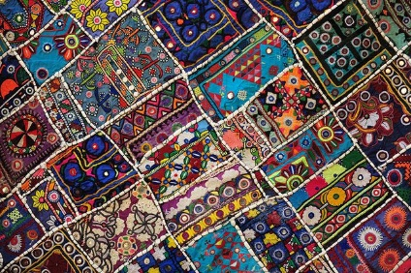  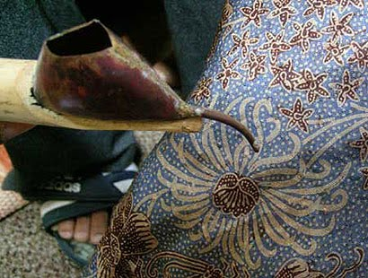 |  |  | 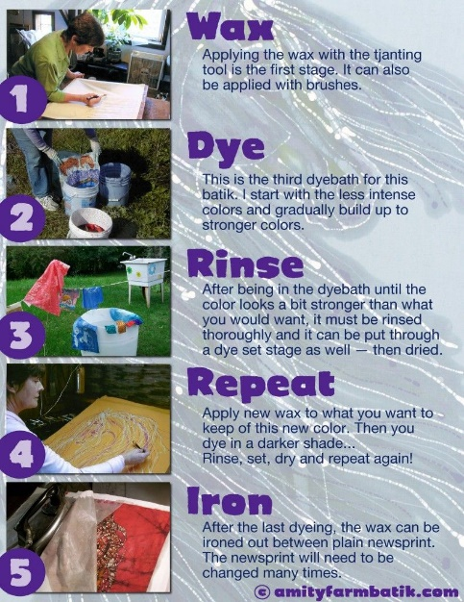  - Use fabrics to create 3D structures.  - Use different grades of threads and needles.  - Experiment with batik techniques.  - Experiment with a range of media to overlap and layer, creating interesting colours and textures and effects.  What skills will I learn?
Artist Study – Malala Yousafzai
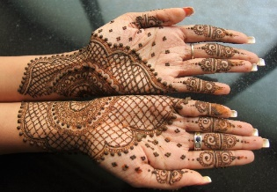  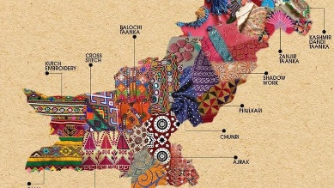  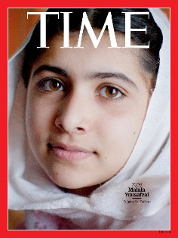  .  Malala Yousafzai, is a Pakistani Pashtun activist for female education. When she was a teenager, she was not allowed to go to school, because her country was controlled by the Taliban. She fought back against the oppression and as a result, was shot by members of the Taliban.  Her family moved to the UK, in order for her to recover from the gunshot wounds. Though Malala still remains linked with her Pakistani culture.  When Malala was a young girl, she would take part in the cultural practice of having Henna designs painted onto her hands. These patterns are beautifully intricate and can also be seen in the clothing in Pakistan.  The textile industry is the largest manufacturing industry in Pakistan. Pakistan is known for producing beautiful materials that contain a variety of bright colours and dazzling applique.  Pakistan is full of a rich an exciting culture. There is so much to learn about this country! |  |  | What will I know by the end of the unit?
- Textile art is the process of creating something using fibers gained from sources like plants, animals, insects (think silk worms!), or synthetic materials.
- Making textiles is an extremely old art form. Textile fragments have been found dating back to prehistoric times. Examples of textiles include tapestries, rugs, quilts, and of course clothing.
- People also used textiles to make objects that signaled status or commemorated important events. Examples of this type of textile include things like flags, military uniforms, or ceremonial banners.
- Many cultures around the world have distinct methods of making textiles by using materials available to them, and some have become famous over the centuries like Chinese silks or Turkish rugs.
- Today, many contemporary artists work with fibers and textiles in new and
exciting ways.
- How to use the above skills to create a piece of textile art inspired by the Artist Malala Yousafzai.

2005 Creates Drawn Stone.
2018 2nd documentary of Goldsworthy released: Leaning into the Wind
Mid-1990s By this point he has become a renowned sculptor.
1997-1998 Creates Storm King Wall.
1982 Marries the sculptor Judith Gregson, and they move to Scotland.
1975-1978 He begins to explore the outdoors as an art studio whilst at University.
1999 Creates Wet Feathers…
1974 He is accepted as a foundation student at Bradford College of Art.

2000 Receives an OBE for his services to art.
2002 Finishes creating Refuge d’art.
1969 Begins to spend his weekends working on a farm.

July 25th, 1956 Goldsworthy is born in Sale Moor, Cheshire.
Andy Goldsworthy Timeline

