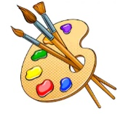
Year 3 Art Digital Media
KNOWLEDGE ORGANISER
Who are refugees? |  |  | What skills will I learn? |  | Key Vocabulary  Art  Palette  Style  Refugee  Awareness  Eye-catching  Empathy  Bright  Bold  Digital  Media Combine  Special Effects  Present  Store
A refugee is a person who has been forced to leave their country in order to escape war, persecution or natural disaster. Every year, millions of people are forced to flee from their homes in order to keep safe,  How could you use digital media and digital artwork to raise awareness of refugees?  Where would the artwork need to be placed?  What information would it need to share?  How would you make it eye-catching and intrigue the audience? | 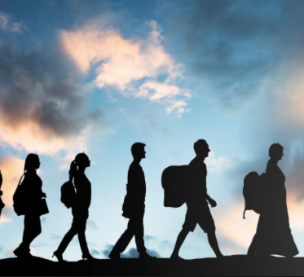 |  | - Record, collect and store visual information using digital cameras, video recorders, etc.  - Present recorded visual images using software.  - Use a graphics package to create images and effect with;  - Lines by controlling the brush tool with increased precision.  - Experiment with colours and textures by making an appropriate choice of special effects and simple filters to manipulate and create images for a particular purpose.
What steps do I need to follow to create my artwork?
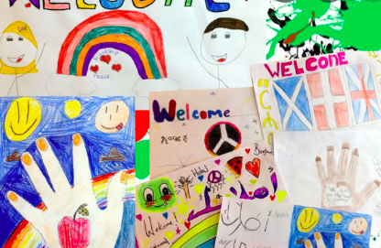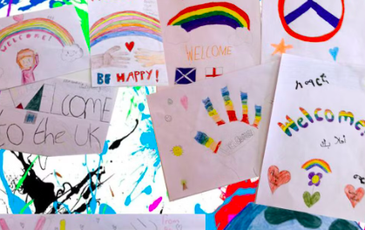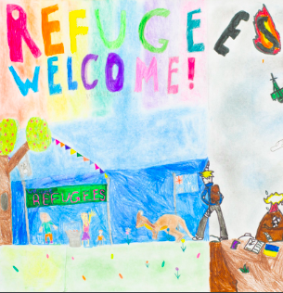  1. Research and collect images about refugees.  2. Save these images onto the I-Pad or computer.  3. Upload my images onto Purple Mash – 2PaintAPicture  4. Add text or your own drawings onto the image.  5. Present your artwork to raise awareness of refugees.  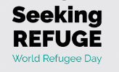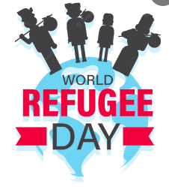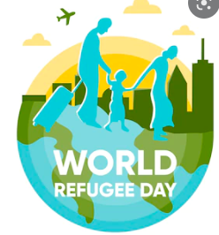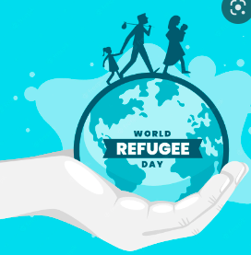 |  |  | What software will I use?
