Topic: Music - Bringing Us Together Unit 5 | Year: 3 | Strand: Disco, friendship, hope and unity
What should I already know?
- Style/theme of song
- Identify instruments and voices
- Find a pulse
- Sing in 2 parts
- Play instrumental parts – GAB
- Improvise GAB
- Compose DEGAB
- Perform

Vocabulary
Keyboards
Drums
Bass
Imagination
improvise
Compose
- Disco
Pentatonic Scale
Pulse
Rhythm
Pitch
Tempo
Dynamics
Texture Structure
Hook
Riff
Melody

Links
Maths – counting, recognising numbers
Phonics – recognising letters
Speaking and Listening
PHSCE –Performing as a group

Skills (subject specific)
- Find the pulse
- Identify instruments and voices
- Do the words tell a story?
- Sing in 2 parts
- Play instrumental parts – CAG
- Improvise CA
- Compose CDEGA
- Perform

Listen & Appraise
- Find the pulse
- Instruments/voices?
- Do the words tell a story?

Musical Activities – using glocks and recorders
- Warm up games
- Singing in 2 parts
- Play instrumental parts -CAG
- Improvise CA
- Compose using CDEGA
Supporting Songs and Styles
- Good Times by Nile Rodgers Ain’t Nobody by Chaka Khan We Are Family by Sister Sledge Ain’t No Stopping Us Now by McFadden and Whitehead Car Wash by Rose Royce
- Bringing Us Together by Joanna Mangona and Pete Readman
- Disco

Perform
- Decide how to perform.
- Record it
- This will Include – improvisation, instrumental performances or composition.
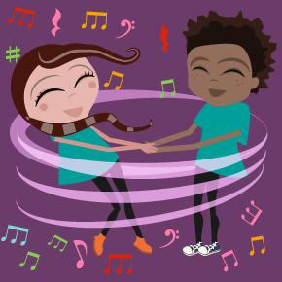
b

