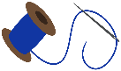
YEAR 3 D.T: TEXTILES
KNOWLEDGE ORGANISER
Overview |  |  |  |  | Designing |  | Key Vocabulary  Textiles  Sew/ Stitch  Thread  Needle  Appliqué  Seam  Aesthetics  Running Stitch  Back Stitch  Over Sew Stitch  Blanket Stitch
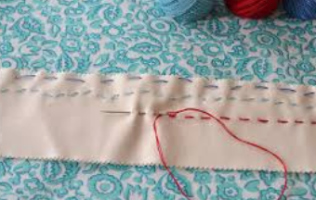  Sewing Techniques  Textiles are flexible materials woven from fibres  -Textiles are used to make clothing, sheets, towels, linen, carpets, rugs and a wide variety of other products.  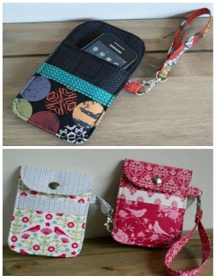  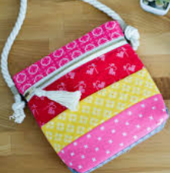  -Sewing involves the joining of different textile fabrics using a needle and thread.  -Sewers can use a range of different sewing styles to produce strong joins.  -Some stitches also create an attractive-looking seam (a line of stitching joining fabrics together). Thinking about the way a product looks is called ‘aesthetics’, and is highly important in textiles. |  |  |  |  | Designers of textile products need to think about the purpose (what does it do?) and the user (who will use it?)  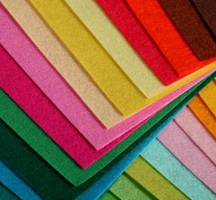  Fabrics -Different fabrics have different properties (characteristics) which make them good for different purposes. For example, some are soft and provide a cushion (e.g. felt) whilst others can be thin and lightweight (e.g. silk, cotton). This can make them easier to join/ decorate with.  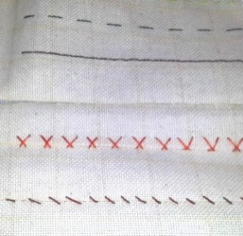  Joining – There are lots of different stitches that you could use to join the fabrics together (see below). Some are easier and quicker, (e.g. running stitch) some are more secure and do not show the seam as obviously (e.g. backstitch), some help to improve certain fabrics (e.g. overstitch) and some are more aesthetically pleasing (e.g. blanket stitch).  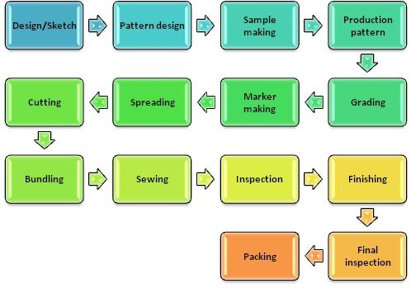  As a part of the design process, you should be able to sketch and annotate different ideas. You should also be able to plan the main stages of making, using either a checklist, a storyboard, or a flowchart.
Example Textiles
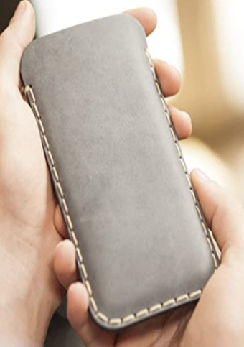 | Phone Cases  Can be made with cotton/ floss thread/ leather  Decorated using running back stitch |  | -Phone Cases are designed to protect the phone inside them – phones are often very expensive! Therefore they need to be soft and durable.  -Rubber and leather are good materials for phone cases, because they are tough. However, cotton/ woolen fabrics are sometimes used as they offer a soft cushion for the phone.  -The pictured product has used a backstitch for joining fabrics together. This is a particularly strong stitch, that will keep fabrics together securely.
 |  |  |  |  | Making & Evaluating
 |  |  |  |  | Making  -Here is a guide to the different stitches that you may use to join fabrics together:  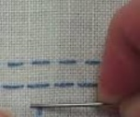  Running Stitch – This is the simplest stitch. It creates a dotted line effect. Remember to leave a space from the previous stitch.  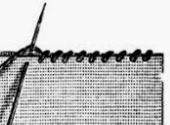  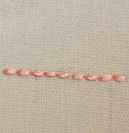  Back Stitch – Similar to the running stitch, except that the thread doubles back so that there is no visible spacing between stitches. It is a very strong and secure stitch.  Over Sew Stitch – The over sew stitch is a good way to neaten the raw edge of fabrics. It involves sewing over the edge of the fabrics.  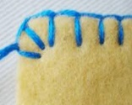  Blanket Stitch – Another way to reinforce the edges of thick materials. This stitch is popular as it is thought to be aesthetically-pleasing. | Evaluating  -How does your textile look? Would your user like it? Why or why not? How could you improve the way it looks?  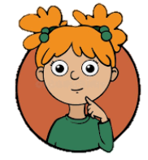  -Are your attached fabrics secure? How did you achieve this? Which type of stitch did you use? How could fabrics be joined more securely?  -Which materials did you choose? Why? Does your product perform its purpose well? Why or why not?  What do you like about your product? How could you improve your product?
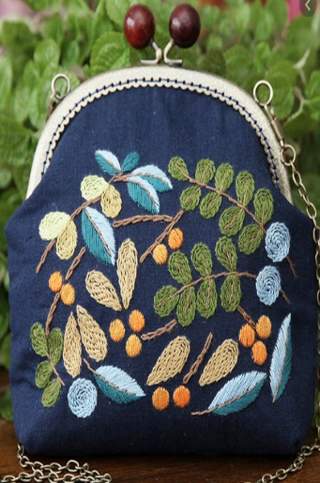 | Purses and Wallets  Made with many different materials  Joined with Blanket Stitch technique and decorated using cross-stitching |  | -Wallets and purses can be made using a wide variety of materials. They are designed to be durable, to keep contents safe, and yet also to be aesthetically-pleasing.  -This purse has been joined using the blanket stitch technique. Whilst this can be quite time-consuming, it creates an attractive seam and a secure join.  -The creator has then created elaborate embroidery patterns to decorate the purse.

Make sure that you are wearing the correct equipment for tasks.
Follow the teacher’s cutting instructions carefully.
If you need to move around with scissors, hold around the closed blades, facing down.
-When you are not using your needle, keep it in the same safe place.
-When using a needle, keep your fingers well clear. Use a thimble where available.
-Walk safely and calmly around the classroom/ workshop.
Report any accidents & clean up properly after yourself.
-Remove any jewellery and tie back long hair.
Health and Safety

