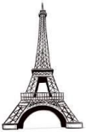
KNOWLEDGE ORGANISER
Overview  YEAR 5 D.T: FRAME STRUCTURES |  |  |  | Designing – How do I design a strong, stable, secure frame structure? |  | Key Vocabulary  Structures  Frame Structures  Rigid  Beam  Column  Slab  Joints  Foundations  Triangulation  Bracing  Malleable  Horizontal  Diagonal  Vertical
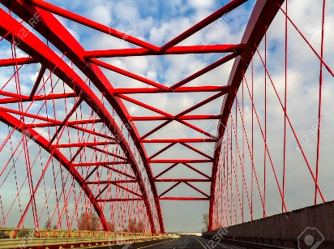  Frame Structures  You should already know that structures are things that are built for a purpose, for example to support something or hold something.  -Frame Structures are rigid support structures that use beams, columns and slabs to hold large forces of gravity and weight.  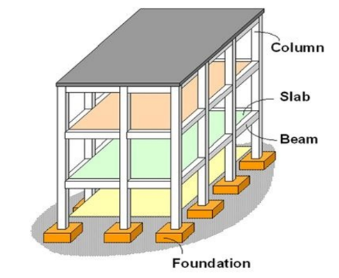  -Frame structures give shape, and are useful for support & weight bearing.  -Unlike shell structures, frame structures have joints, which are formed according to the design requirements and materials being used.  -Some examples of man-made objects that use frame structures are houses, skyscrapers, bridges, scaffolding, tables, and roller coasters!  -The system of beams and columns in a frame structure can be further strengthened through the use of other features, e.g. foundations, bracing. |  |  |  | -Remember your prior learning, a wider base can help a structure to be more secure.  -Frames should be able to stand on their own, providing a ‘skeleton structure.’  -You may wish to consider a foundation/ anchoring system, where appropriate.  You should be able to consider the most appropriate materials for your frame structure, considering a number of properties (e.g. weight, toughness, malleability, strength and presentation) depending upon the nature of your project.  -You should also be able to consider restraints, for example time and cost.  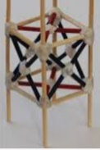  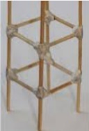  Triangulation can help to make structures stronger. This is important to consider when creating stable joints (see the making section below for this).  -Triangulation is also important when bracing. When force is applied to one point on the triangle, the pressure is shared amongst the other two points, which provide a secure wide base. Using bracing, you can create triangular shapes, can therefore make your structure more rigid from different angles.  Triangulated bracing adds to rigidity.  Design stage should include: step-by-step plan, annotated sketches, listing tools & materials.
Example Structures |  |  |  | Making & Evaluating
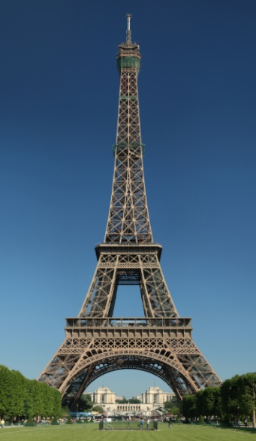 | Name: The Eiffel Tower  Location: Paris, France  Height: 324m  Built in: 1889  Purpose: Observation/ Broadcasting Tower  Materials: Wrought Iron | -The Eiffel Tower is one of the most famous structures in the world. The main architect who designed the Eiffel Tower was Stephen Sauvestre, whilst Gustave Eiffel was the chief engineer.  -The wrought-iron structure is based of four huge arched legs, set on masonry piers that curve inward.  - The material used to make this tower is wrought iron which has is tough, malleable (can be pressed into shape without cracking) & corrosion-resistant.  -Sauvestre and Eiffel wanted to prove that the metal could be as strong as stone, whilst lighter.  -It uses a diagonal bracing structure throughout, to prevent side-to-side movement in the wind. |  | 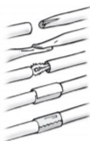  Making  One straw creased & secured inside the other.  Flattened & glued  Pipe cleaner used inside  Card sleeve glued around joint  Sticky tape  Using Straw/Rolled Paper  -When using straw, rolled paper, a number of adhesives can be used – e.g. sellotape, different types of glue.  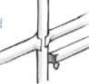  -However, these structures are not as strong/ stable as wooden structures.  One straw split and glued around the other  Glued to card  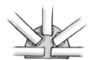  -Creating a rigid frame requires the creation of secure joints.  -These can be made using the methods shown on the right.  Using Wood  -When using wood, PVA glue is most appropriate. Joints should be securely clamped together to allow for drying time.  -Card strips can be used to create secure joints.  -Card triangles can be used to create secure corner joints.  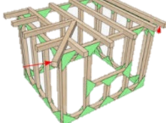  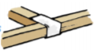  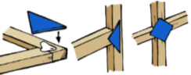  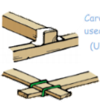  -One suitable alternative is elastic bands, which can be securely fastened around beams and columns, in order to create secure joints. | Evaluating  -How well does your structure work? Does it meet its purpose?  -How did you make your frame structure strong and rigid?  -How could you make it more strong and rigid?  -Which materials did you use? Why did you make these choices?  What restraints did you have? How would you have changed your product without these restraints?  -How did you cover your frame? Was this the best material? Why or why not?  -How does your product look? How could it look more appealing?
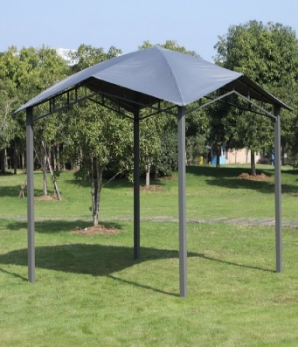 | Name: Gazebos/ Tents  Purpose: Shelter/ Temporary Habiting Space  Materials: Wood, iron or aluminum & canvass. | -Tents and gazebos are shelters made up of sheets of fabric/material, draped over a frame structure.  -The frames are often made of iron or aluminium poles (lightweight, which make them easy to transport/ erect/ deconstruct) or wood.  They can range in size, from simple ‘bivouac’ structures for one person, to huge circus tents for thousands of people.  -Rather than foundations, hooks or pegs are ordinarily used to anchor tents to the ground.

Make sure that you are wearing the correct equipment for tasks, including safety goggles.
Should you need to move around with sharp objects, hold them appropriately.
Follow the teacher’s cutting/ machinery instructions carefully.
Report and clean all spillages & other potential hazards.
Keep your work area and floor area clear – regularly tidy up to avoid accidents.
-Walk safely and calmly around the classroom/ workshop.
-Wear an apron where necessary and roll up your sleeves.
-Remove any jewellery and tie back long hair. Keep belongings clear.
Health and Safety

